2014 Schedule of Activities

Date | Location | Type | Host
January 31, 2014 | Carrier and Gable, Farmington Hills | Board Meeting
March 9-12, 2014 | Miami, FL Hyatt Regency Miami | ITE International 2014 Technical Conference and Exhibit | ITE International
March 18, 2014 | Lansing, MI, Royal Scot Golf and Bowl | *Technical Session | Kim Lariviere  517-373-3889
April 14-15, 2014 | Indianapolis, IN  Omni Severin Hotel | ITE Great Lakes District - 2014 Annual Meeting | Indian Section ITE  Sandra Jones  317-287-3414
May 29, 2014 | Mystic Creek GC, Milford | Education Fund  Golf Outing | Aimee Giacherio  616-363-8181
August 10-13, 2014 | Seattle, WA Washington State Convention & Trade Center | ITE International 2014 Annual International  Meeting and Exhibit | ITE International
August 19, 2014 | Lansing, MI | Board Meeting
September 18, 2014 | Willow Wood GC, Portland | Fall Golf Outing | Tim Haagsma  616-242-6923  Aimee Giacherio  616-363-8181
October 16, 2014 | Kalamazoo, MI, TBD | *Technical Session | Jun-Seok Oh  269-276-3216
TBD | TBD | *Annual Meeting/  3rd MiTEC/  Technical Session | Jeff Bagdade  248-539-2222
* Session Includes Board Meeting

National Meetings
August 10-13 ITE 2014 Annual Meeting
Seattle, WA
March 9-12 ITE 2014 Technical Conference and Exhibit, Miami, FL



Michigan Section
of the

Institute of

Transportation

Engineers

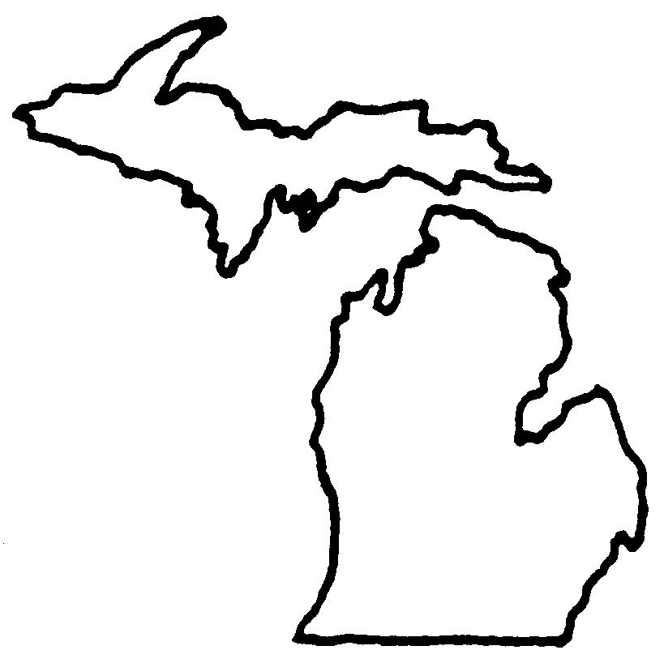

www.itemichigan.org

About ITE and the ITE Michigan Section

The Institute of Transportation Engineers (ITE), an international individual member educational and scientific association, is one of the largest and fastest-growing multimodal professional transportation organizations in the world. ITE members are traffic engineers, transportation planners and other professionals who are responsible for meeting society's needs for safe and efficient surface transportation through planning, designing, implementing, operating and maintaining surface transportation systems worldwide.
The ITE Michigan Section's geographic area includes the entire state of Michigan. Our membership currently includes over 150 transportation professionals, students, and technical affiliates who work/reside in Michigan. In general, the Michigan Section hosts 3 technical sessions (March, October and December) where technical presentations are made to the broad transportation community. The section also hosts two golf outings per year. The May golf outing raises funds for the Michigan Section’s educational fund that has distributed $8000 per year in scholarship grants
With assistance from the Michigan State University student chapter of ITE, a student chapter of ITE was established at the Volgograd State University of Architecture and Civil Engineering (VSUACE) in Volgograd, Russia in the late 1990’s. This is the only known student chapter of ITE in Russia. More interesting is that this chapter is under the umbrella of the Michigan Section of ITE.

The Russian Student Paper competition was started in 2001, and provides for a $200 first prize and $100 second prize for the winners (US money). This competition is very popular with the Russian engineering students, and some very good papers have been submitted.

The Michigan Section sponsorship for the Student Chapters to attend the TRB Conference in Washington DC is an annual goal. The Section has sponsored students to attend TRB each year. Last year the students that participated were from WSU.

Student assistance for Michigan university students at Michigan State University, Wayne State University, Michigan Technological University and Western Michigan University has been ongoing since 1989. It consists of:
- Student Paper - Started in 1989 with one $100 winner. It has grown to a first place award of $500, and a second place award of $300.
- Scholarships - The first scholarship was awarded in 1992 for $500. The Section now awards four, $2000 scholarships, annually.
The money for this assistance comes from the Michigan Section Educational Fund, largely supported by the Golf Tournament that is held annually in the late Spring, as well as through the generous donations of the Section members.

The Michigan section is very active as can be seen in the schedule of activities with the mission of professional development and advancement of professionals in the traffic and transportation industry and promoting safe and efficient flow of people, goods and services.

For membership information, please contact the Secretary Brent Schlack at 734-327-6670 or via email at schalckb@wcroads.org for more information.

2014 Michigan Section Executive Board

President | Steven Loveland  734-466-4415  steven.loveland@ohm-advisors.com
Immediate Past President | Adam Merchant  586-463-8671  amerchant@rcmcweb.org
Vice-President | Danielle Deneau  248-858-4802  ddeneau@rcoc.org
Treasurer | Paul Arends  616-451-2663  arendsp@michigan.gov
Secretary | Brent Schlack  734-327-6670  schlackb@wcroads.org
Director | Matt Hill  313-310-8239  hillma@pbworld.com
Affiliate Director | Tim DeWitt  248-477-8700  timdewitt@carriergable.com
Great Lakes District Director | Colleen Hill-Stramsak  248-454-6571  chill@hrc-engr.com

